
Name: Yuvaraj.D(192421230)
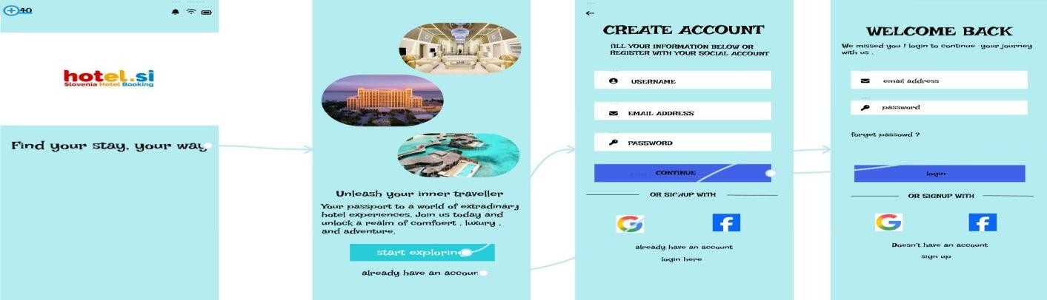
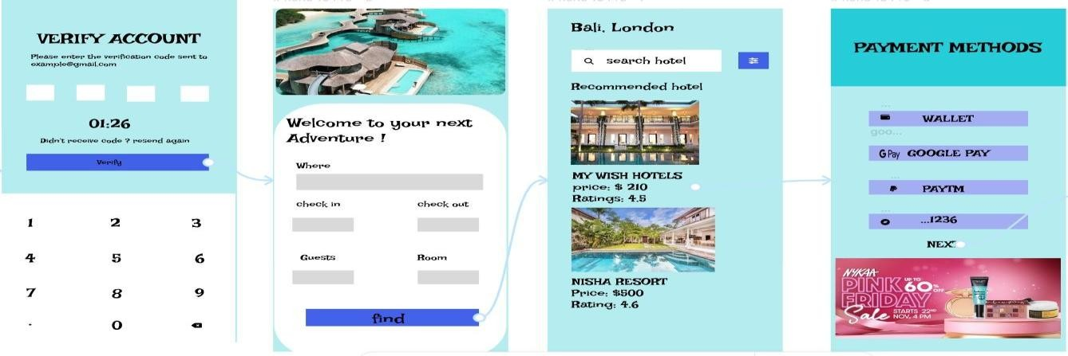



HOTEL BOOKING
S
YSTEM

